**BHAGWATI INTERNATIONAL PUBLIC SCHOOL**

*Dr. Indu Dayal Meshri Primary English School*



INVESTIGATORY PROJECT ON

“ **E-Commerce** ”



Guided by: - Mr. Suresh Patel

Submitted by: - Rohan .D. Patel

Roll no: -

This is to certify that Mr. Rohan Patel student of XII science Roll no ___________worked on project titled- “E-Commerce” held in Bhagwati International Public School during the academic year 2016-2017.

**CERTIFICATE**

He worked sincerely under the guidance of faculties and prepared this dissertation.

**External Teacher Subject Teacher**

**Principal**

ACKNOWLEDGEMENT

First of all, I am immensely indebted to almighty god for his blessings and grace without which I could not have undertaken this task and my efforts would never have been a success.

I humbly consider a privilege and honour to express my heartiest and profound gratitude to Mr. Rajendra.S. Malwal, principal BIPS, Patan. For his appropriate direct*ion, valuable suggestion, under judging assistance so generously extended to me.*

I wish to express my deepest feelings of gratitude to Mr. Suresh Patel, Computer department, BIPS Patan. For his erudite involvement and sustained guidance which has been pivotal in my project work*.* His minute observation, precious insights, critical comments have indeed greatly helped to shape my ideas.

This guidance and support received from my entire classmates who contributed and who are contributing to this project, is vital for the success of this project. I am grateful for their constant support and help.

I also owe sense of gratitude to my parents for encouragement and support throughout the project*.*

***- ROHAN PATEL***

Introduction.

E-COMMERCE:

*Electronic commerce, commonly written as e-commerce, is the trading or facilitation of trading in products or services using computer networks, such as the Internet or online social networks.*

*Conducting business online. Selling goods, in the traditional sense, is possible to do electronically because of certain software programs that run the main functions of an e-commerce Web site, including product display, online ordering, and inventory management. The software resides on a commerce server and works in conjunction with online payment systems to process payments the definition of e-commerce includes business activities that are business-to-business (B2B), business-to-consume.*

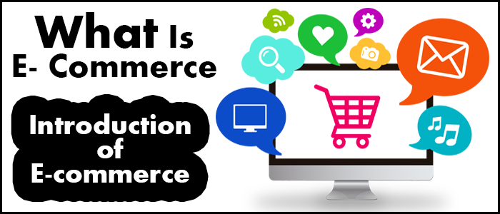

HISTORY.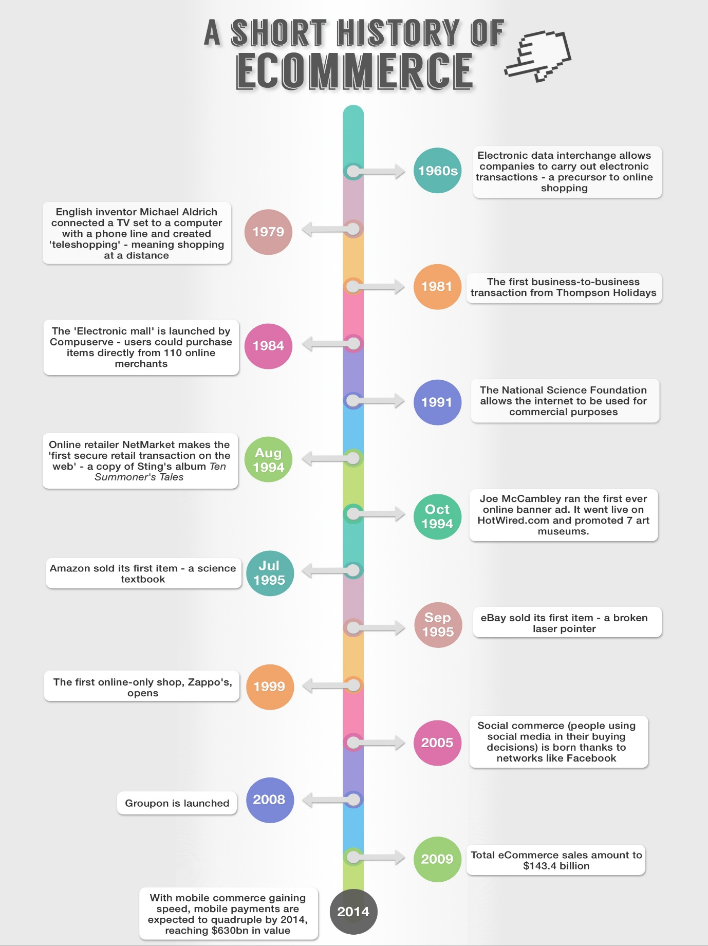

ABOUT OUR PROJECT.

Our project is based on online shopping company named Snapdeal. In our project, it is explained that how the online shopping company (Snapdeal) work’s. It’s made by using NetBeans IDE and MySQL. NetBeans GUI is used as a front end and SQL is used as Back end.

The main idea behind this project is that a customer make his/her account on google and sign in to Snapdeal and purchase a product, his/her details are passed to seller for shipment purpose, and seller letter on can view that details to initiate the delivery process.

And moreover, user can also change password of his/her google account.

In our project, we had made number of frames and we had inter-connected them to facilitate ease of usage. We had used all the basic components.

Basic components used:

* NetBeans IDE
* MySQL RDBMS
* JDBC driver



**With a little taste, of**



ABOUT NETBEANS & MYSQL



NetBeans is a software development platform written in Java. The NetBeans Platform allows applications to be developed from a set of modular software components called modules. Applications based on the NetBeans Platform, including the NetBeans integrated development environment (IDE), can be extended by third party developers.

The NetBeans IDE is primarily intended for development in Java, but also supports other languages, in particular PHP, C/C++ and HTML5.NetBeans is cross-platform and runs on Microsoft Windows, Mac OS X, Linux, Solaris and other platforms supporting a compatible JVM.



MySQL is an open-source relational database management system (RDBMS). Its name is a combination of "My", the name of co-founder Michael Widenius’ daughter, and "SQL", the abbreviation for Structured Query Language. The MySQL development project has made its source code available under the terms of the GNU General Public License, as well as under a variety of proprietary agreements.

MySQL was owned and sponsored by a single for-profit firm, the Swedish company MySQL AB, now owned by Oracle Corporation. For proprietary use, several paid editions are available, and offer additional functionality.



**Vs.**

Cons.

Pros.

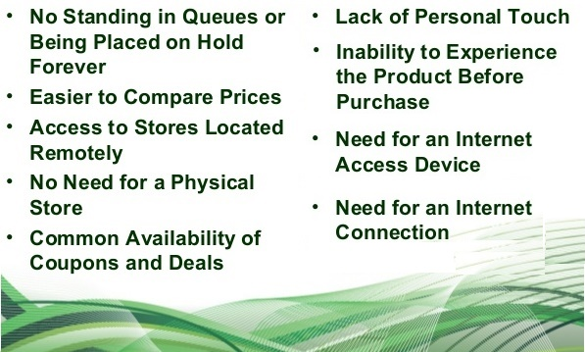





Database Structure.

**Tables in DATABASE named “gmail”**

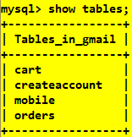

**Table “createaccount”**

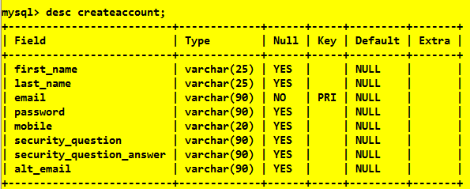

**Table “cart”**

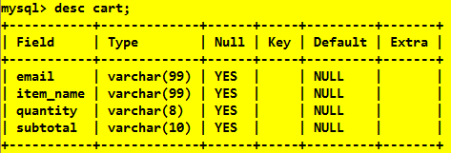

**Table “orders”**

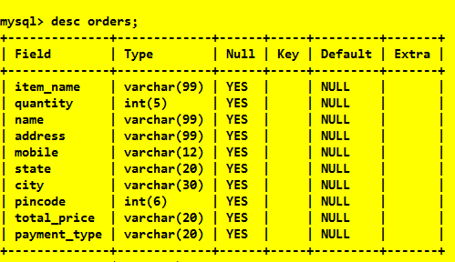

**Table “mobile”**

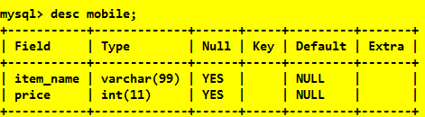

**Data in Table “mobile”**

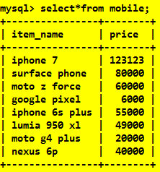 

**WARNING !!! next page’s only for programmers.**

GUI codes! 

First thing first, hear are all the imports and a method that’s common in all frames!

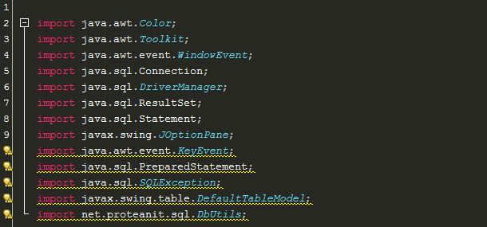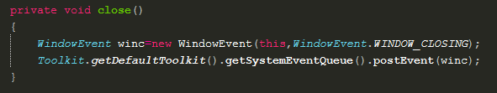

*Createaccount frame*

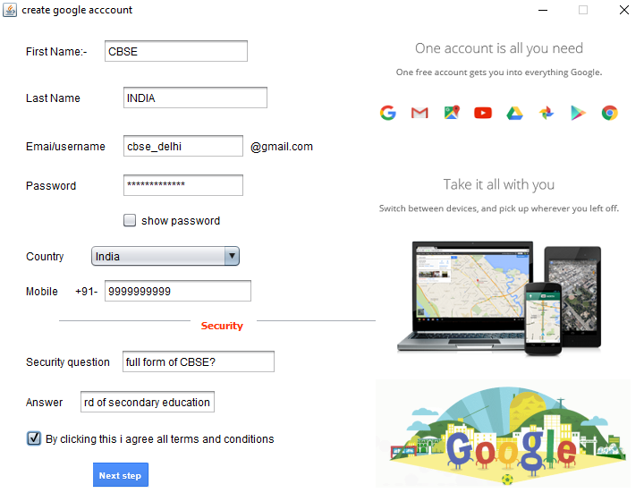

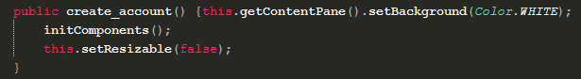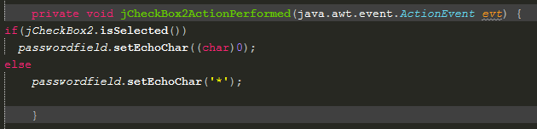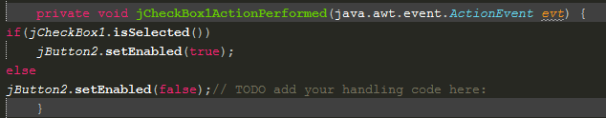

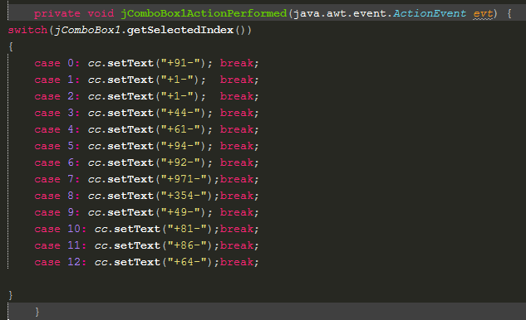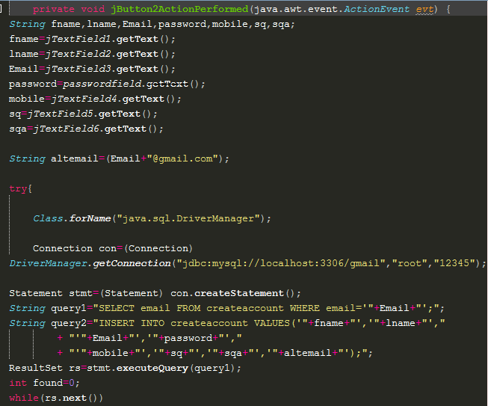

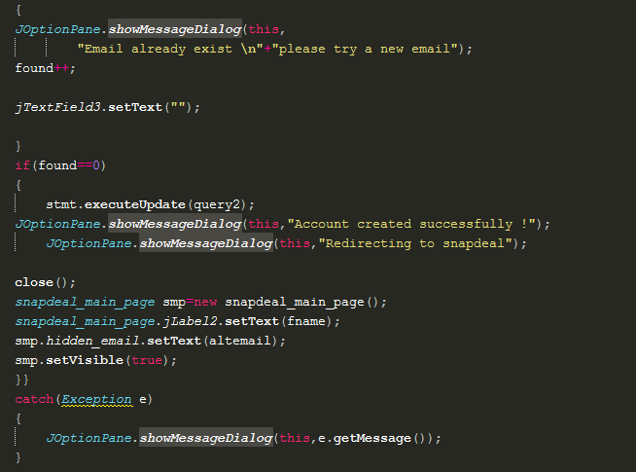

*Snapdeal_main_page Frame*

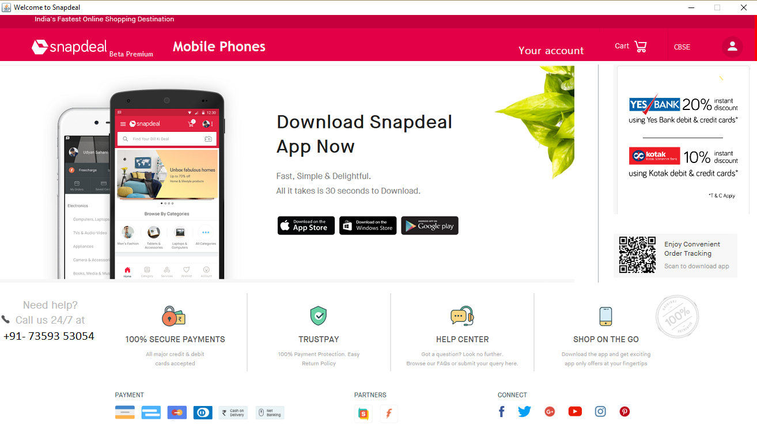

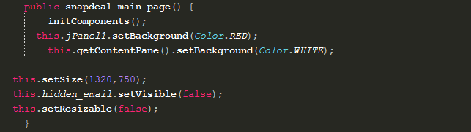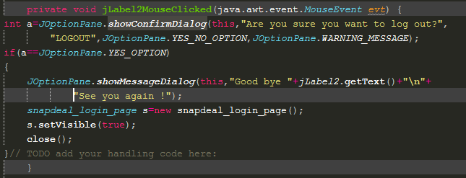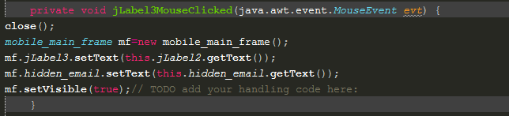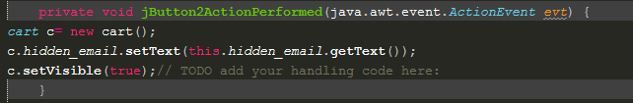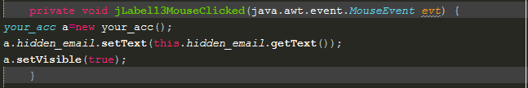

within this frame you can click on your_account frame

*Your_acc frame*

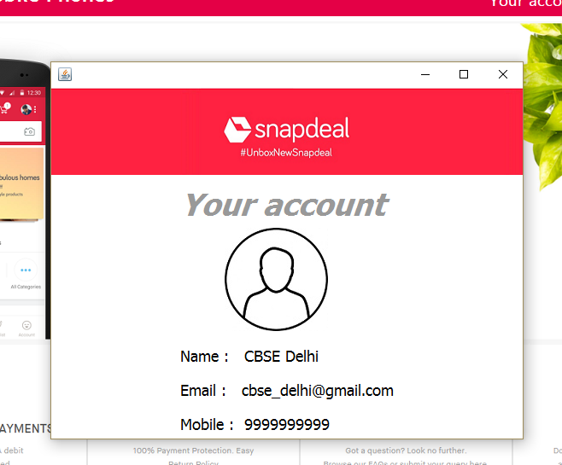

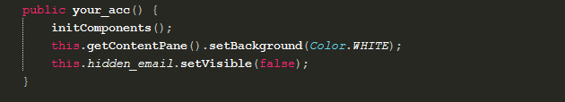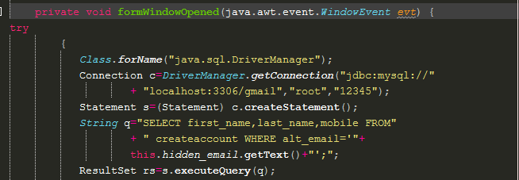

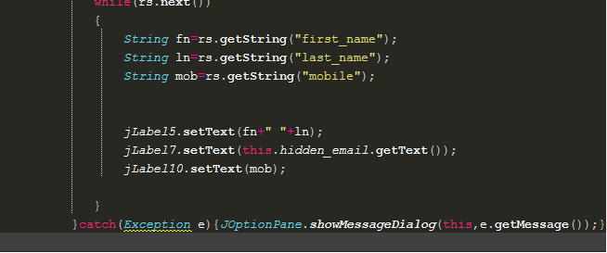

*Mobile frame*

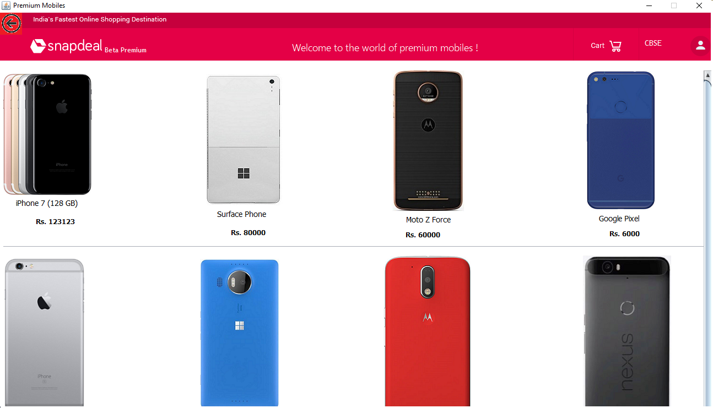

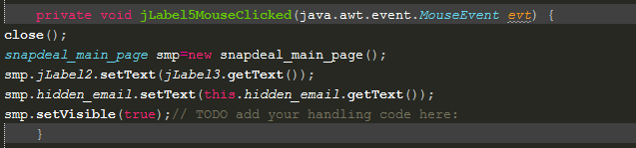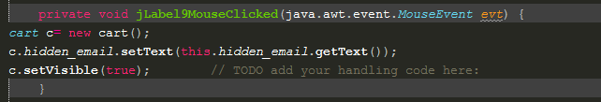

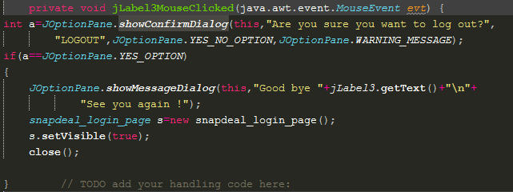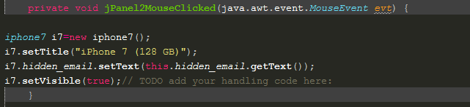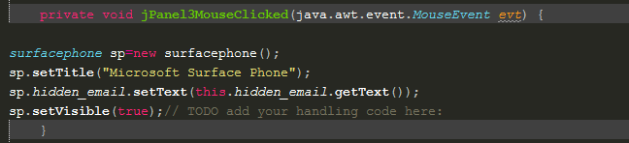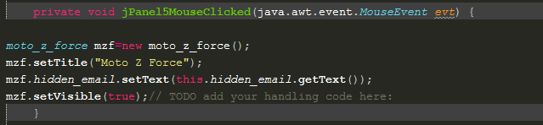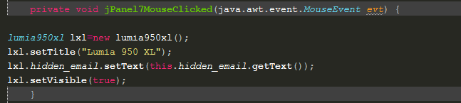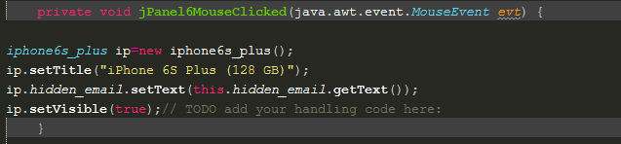

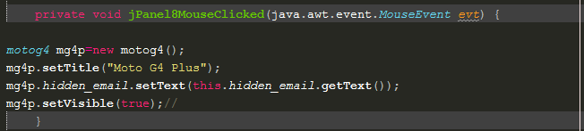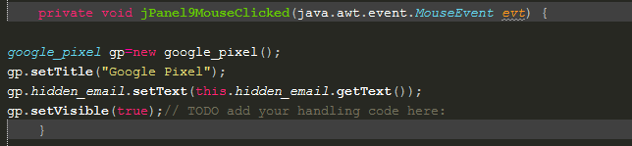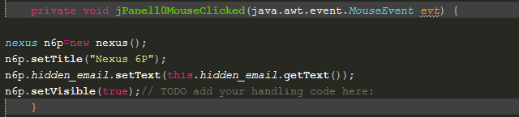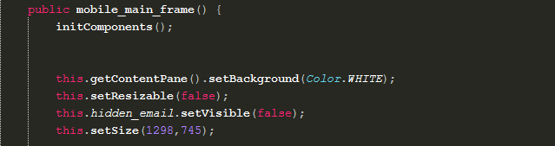

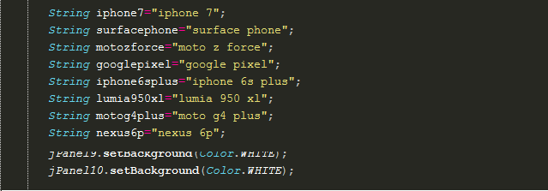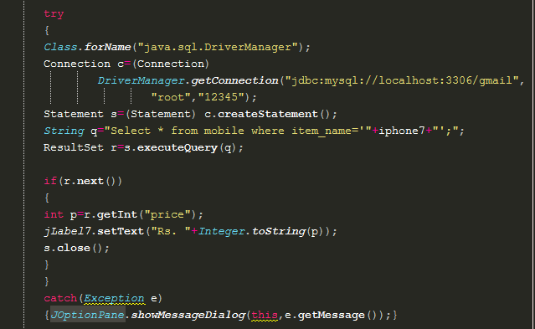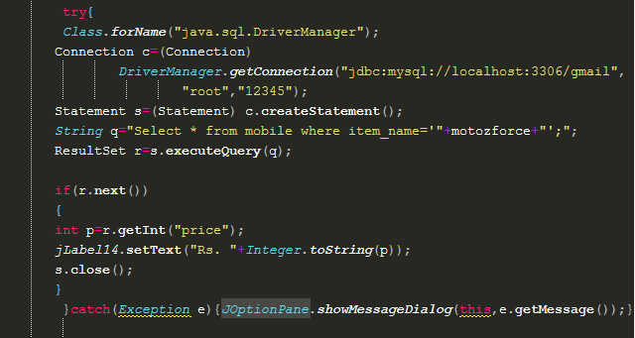

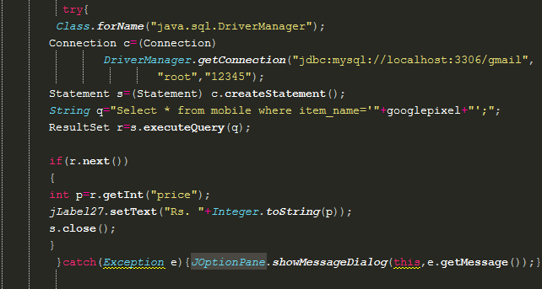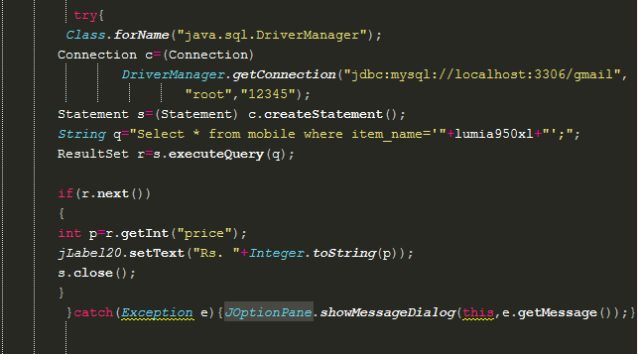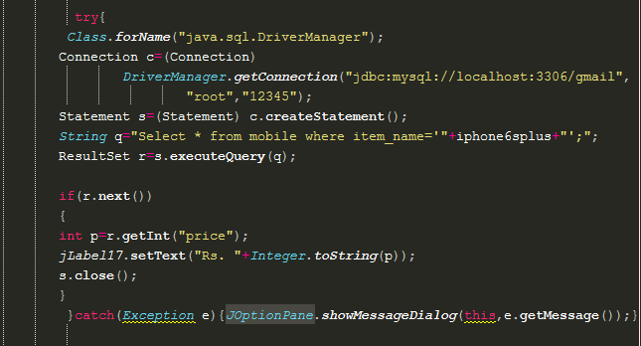

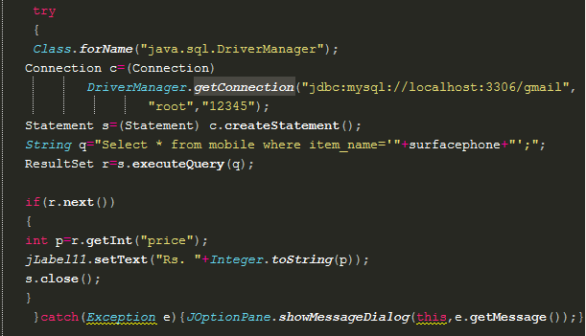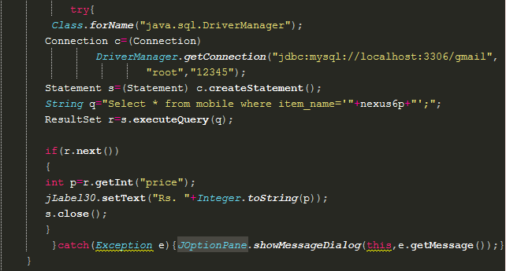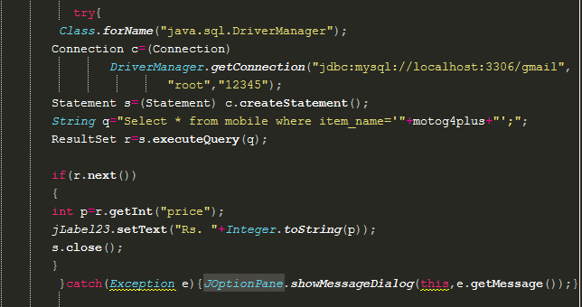

*Iphone 7 frame*

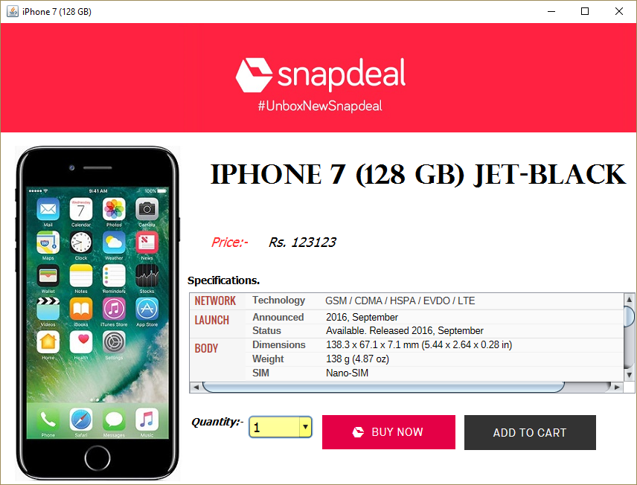

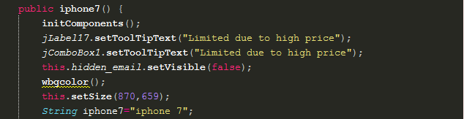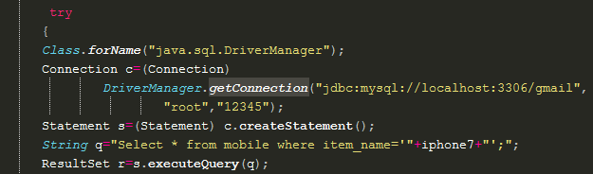

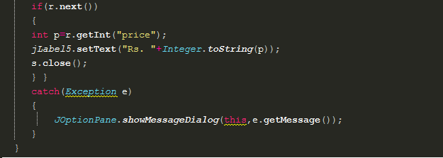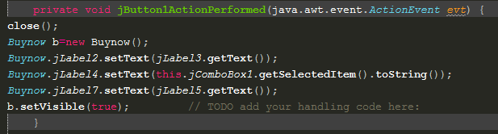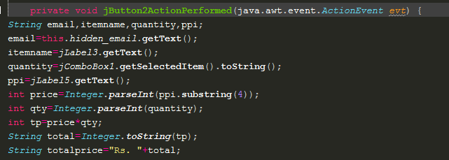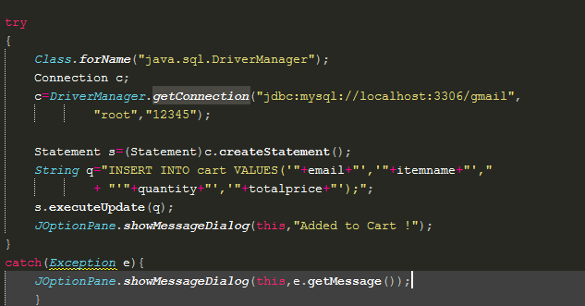

There are 8 another frame for mobiles like the above one, but as they share the same lines of code, we had included only one of them to save PAPER! our project is also ECO-FRIENDLY, we just forgot to intimate you !!



* **92% of the world’s currency exists on computers**. The remaining 8% is in physical money
* TYPEWRITER is the longest word that you can write using the letters only on one row of the keyboard of your computer.
* There are more than 5000 new computer viruses are released every month.
* If there was a computer as powerful as the human brain, it would be able to do 38 thousand trillion operations per second and hold more than 3580 TB of memory.
* The password for the computer controls of nuclear tipped missiles of the U.S was 00000000 for eight years.
* HP, Microsoft, Google and Apple have one very interesting thing in common – they were all started in a garage.
* The first 1GB hard disk drive was announced in 1980 which weighed about 249.4 Kg, and had a price tag of $40,000.
* More than 80% of the emails sent daily are spams.
* An average person normally blinks 30 times a minute, but when using a computer, he/she blinks only 7 times a minute.

*Cart frame*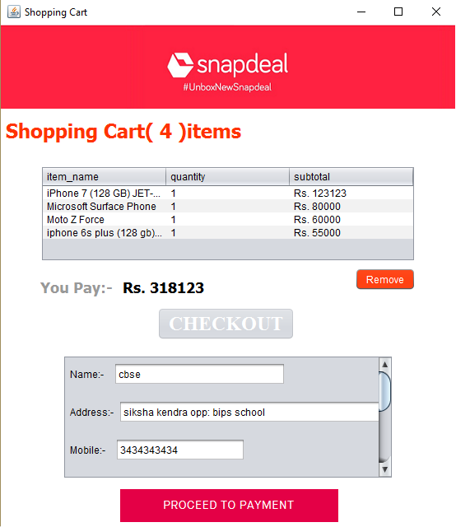

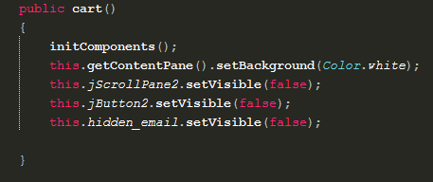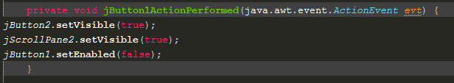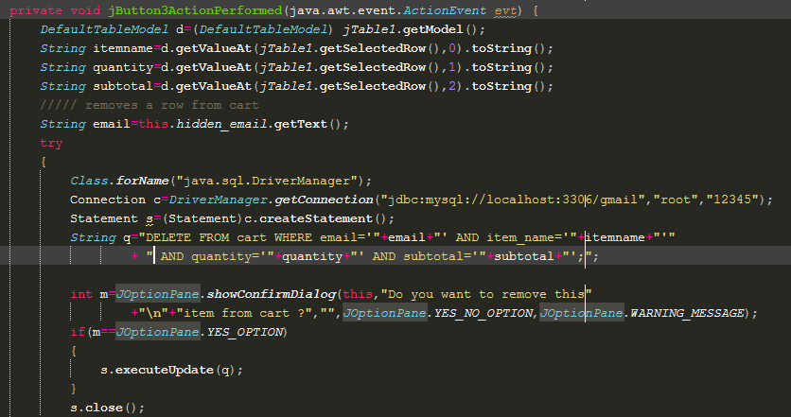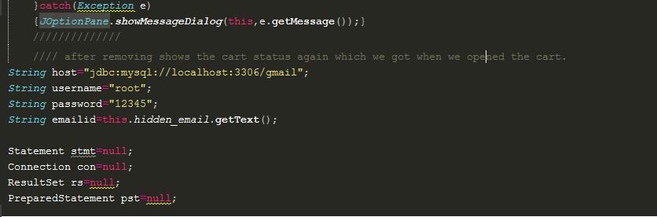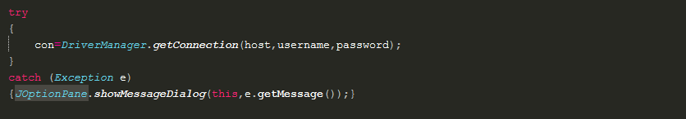

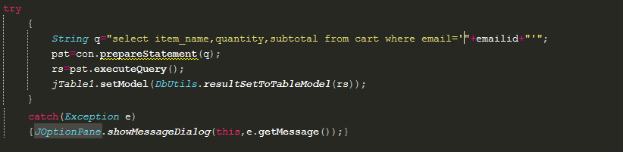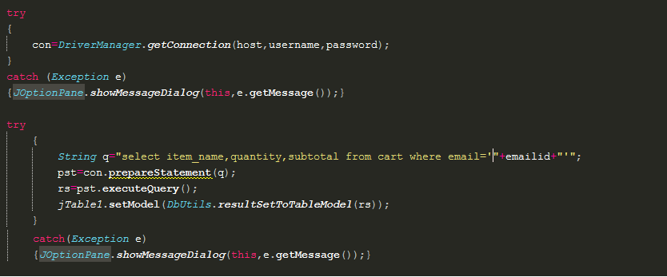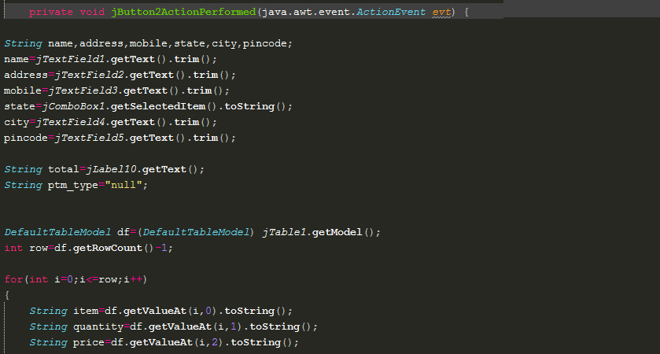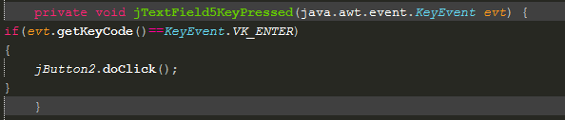

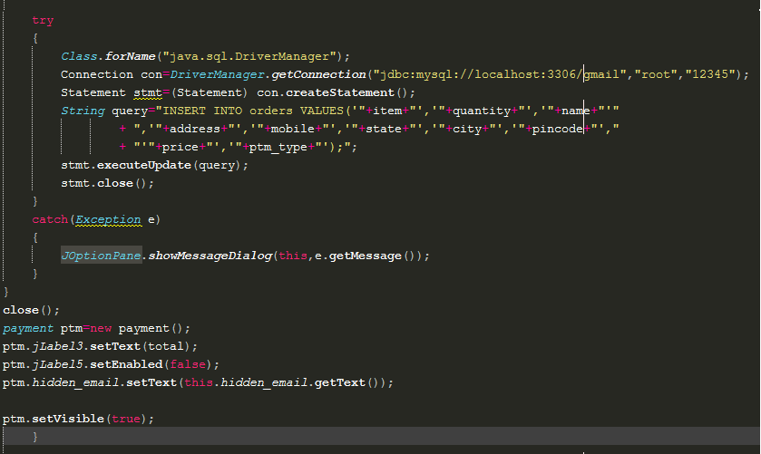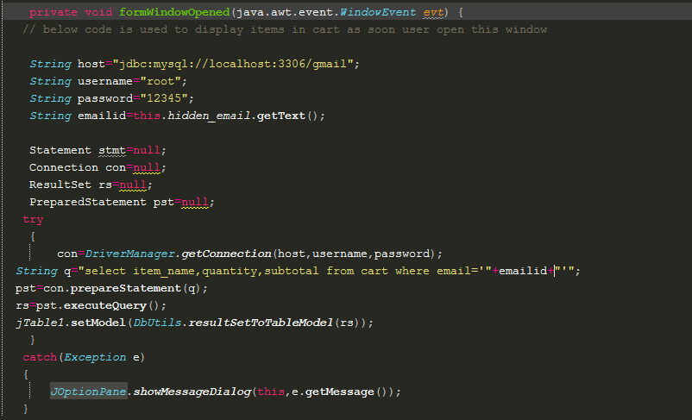

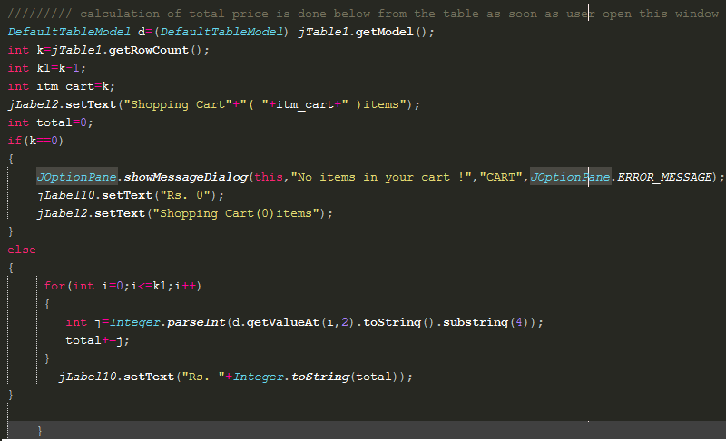

*Buy now frame*

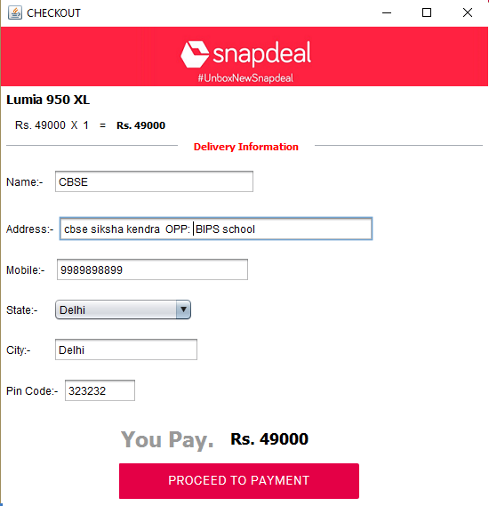

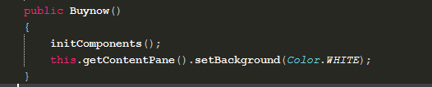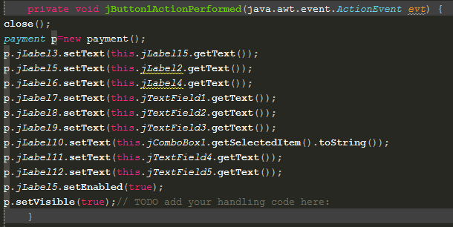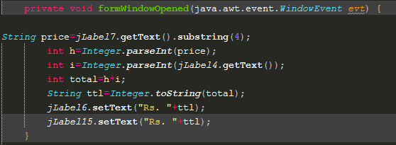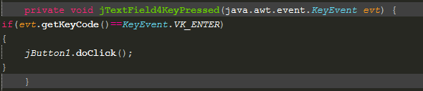

*Payment frame*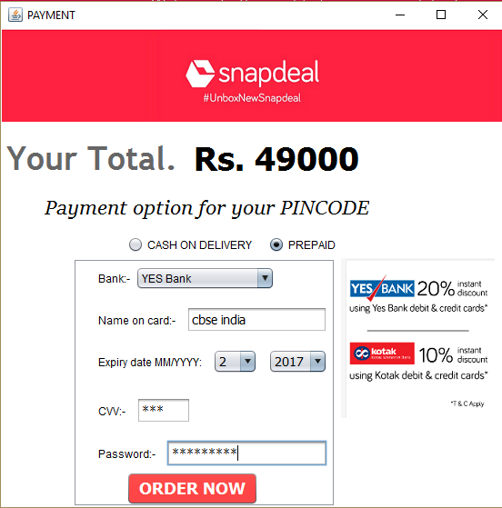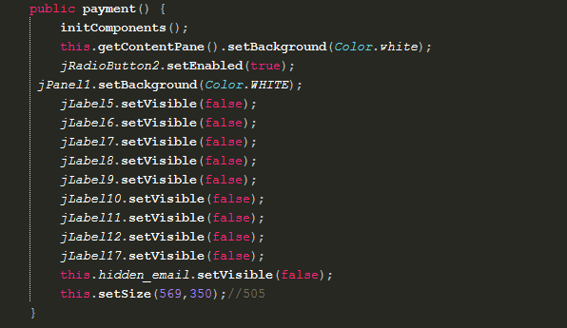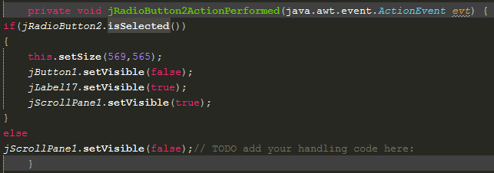

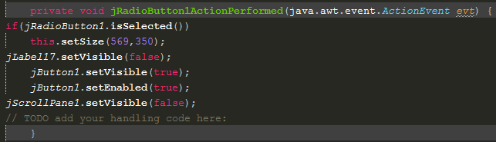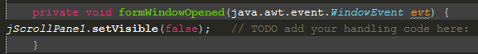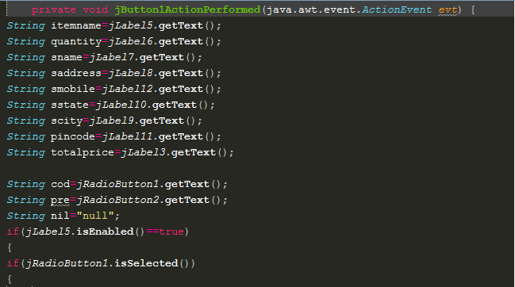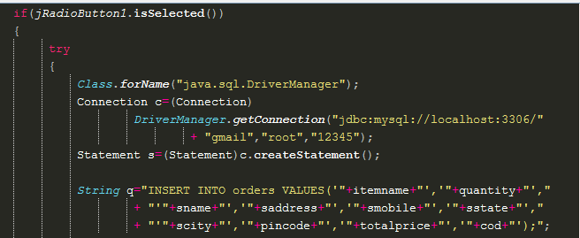

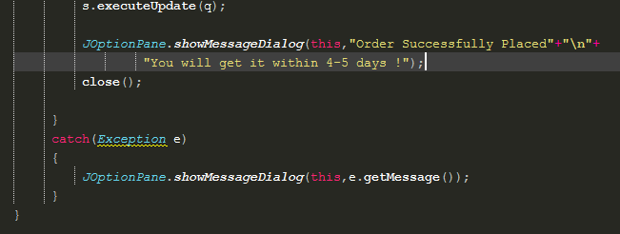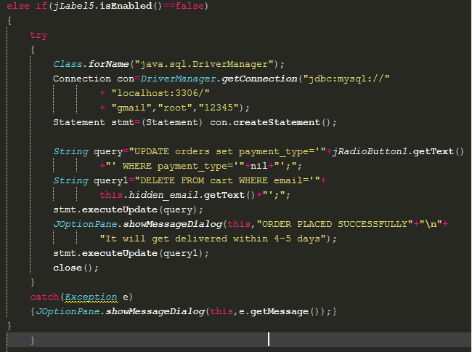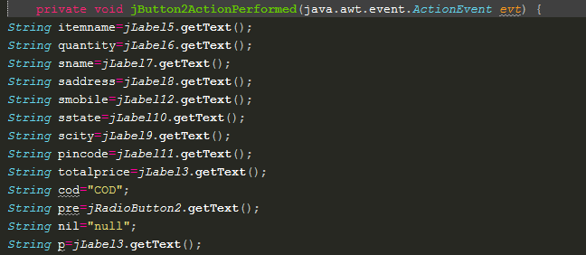

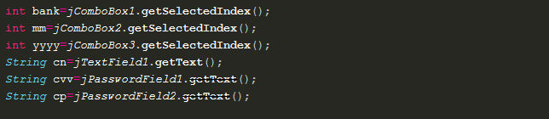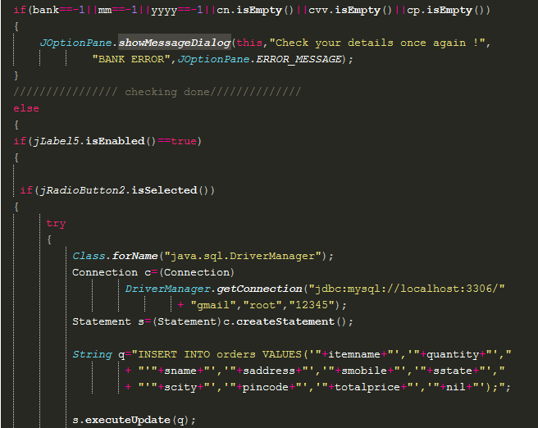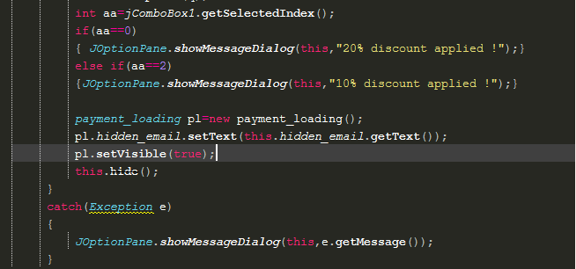

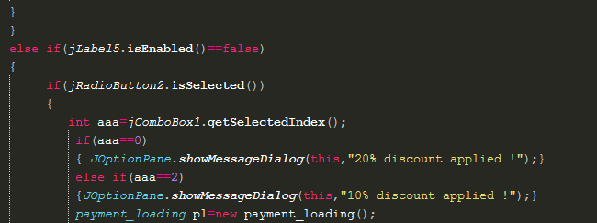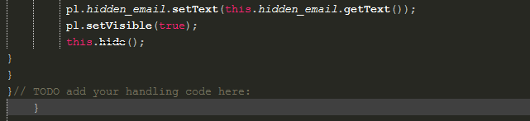

*Payment loading frame*

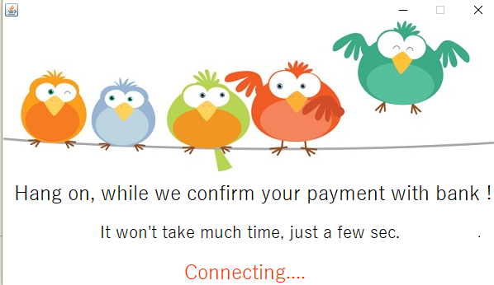

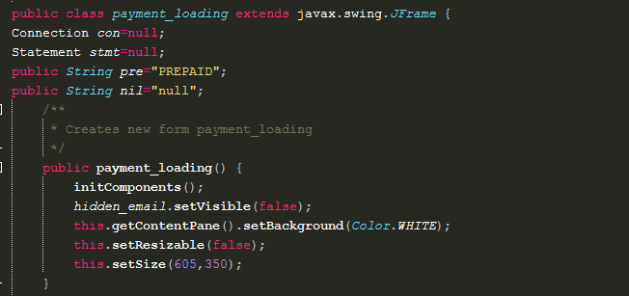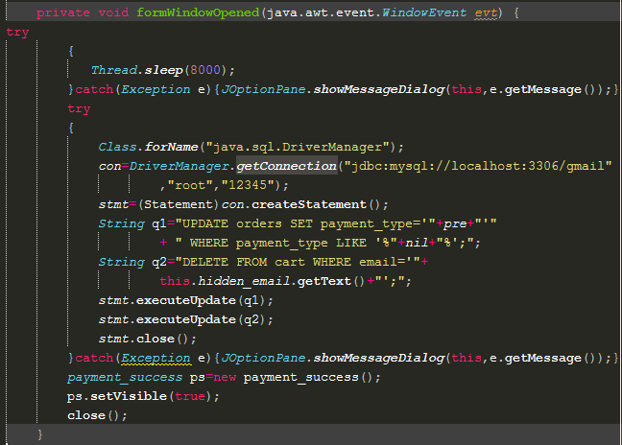

*Payment success frame*

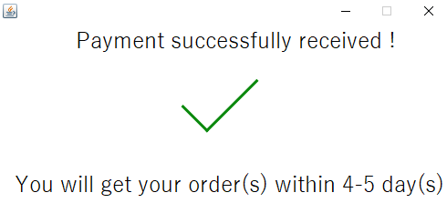

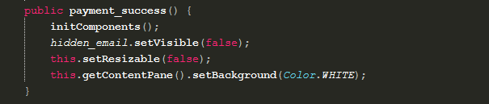

*Snapdeal_seller_page frame*

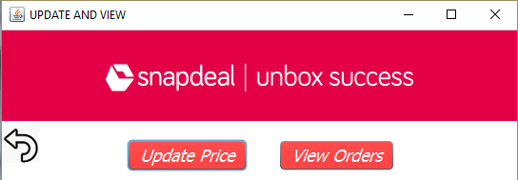

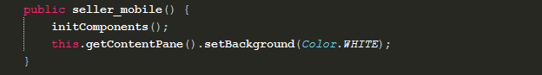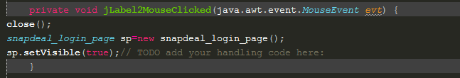

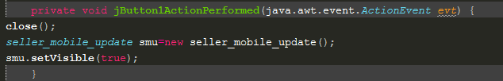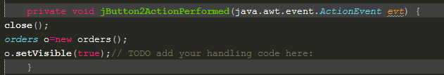

*Seller mobile update price frame*

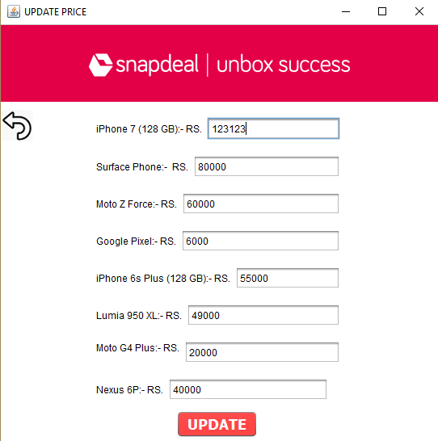

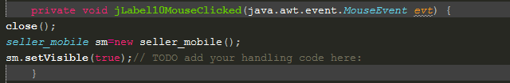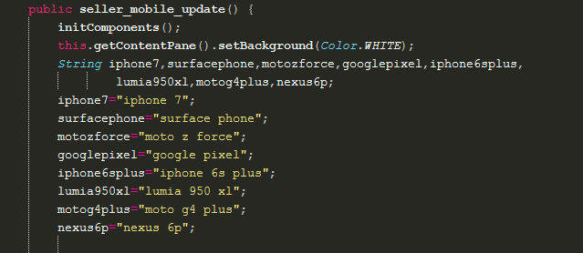

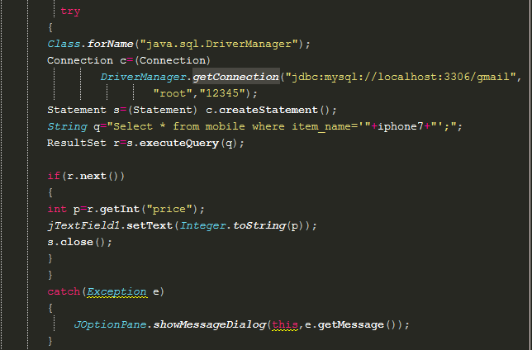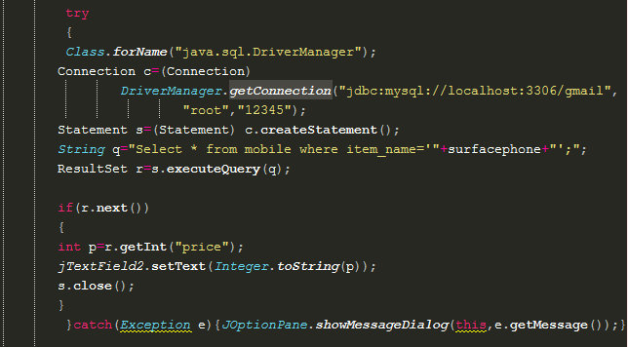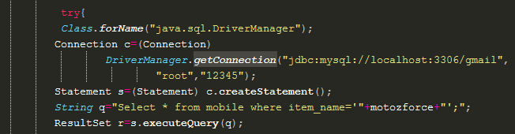

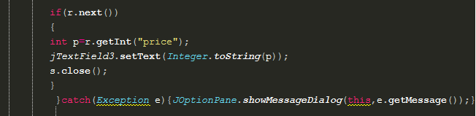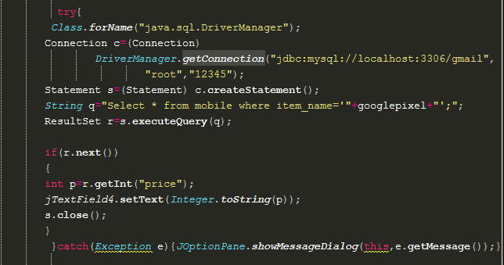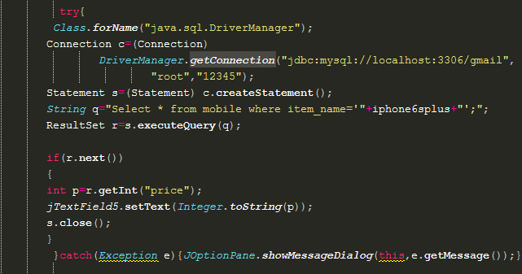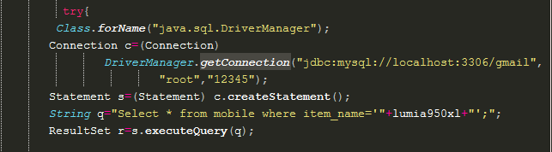

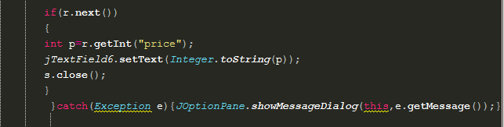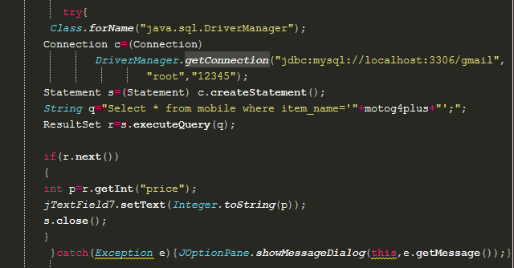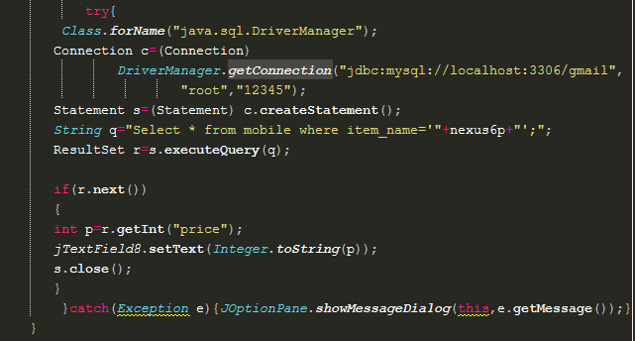

*Seller Orders frame*

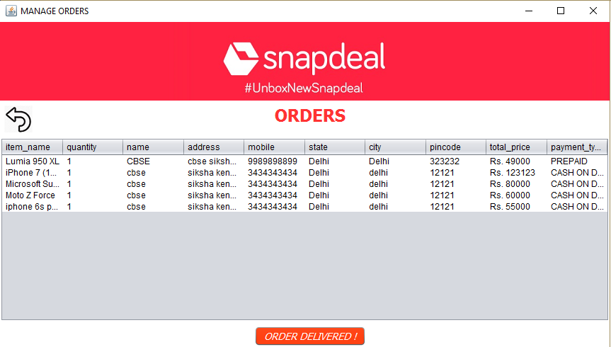

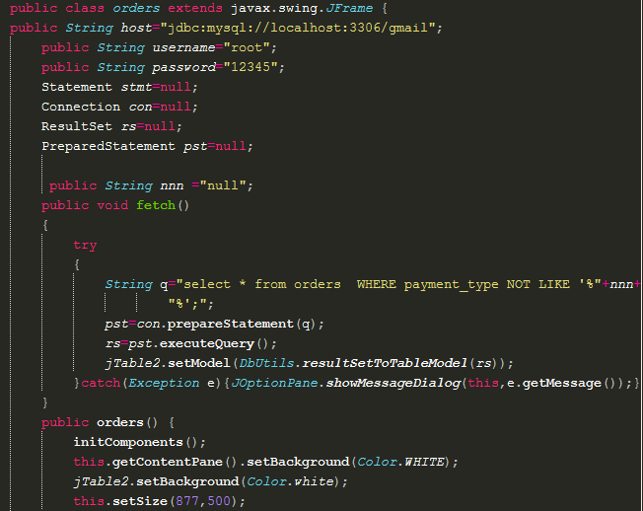

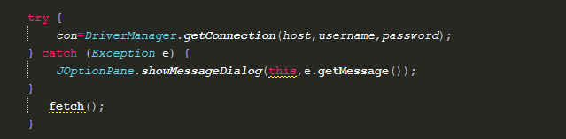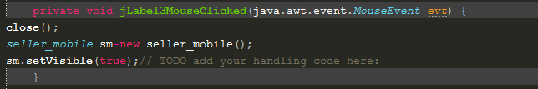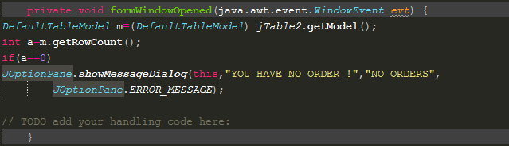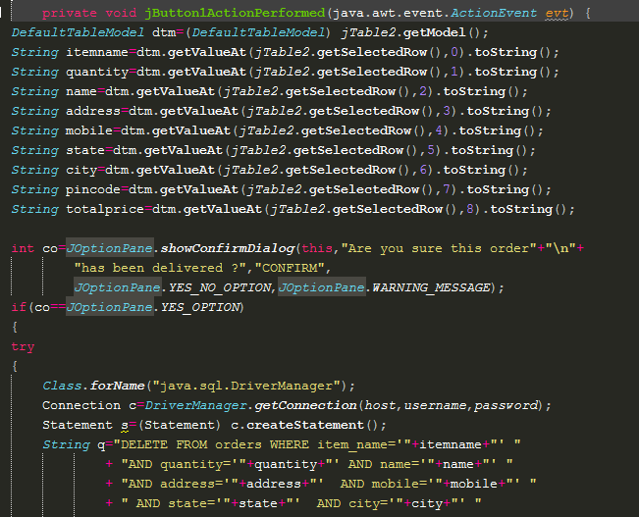

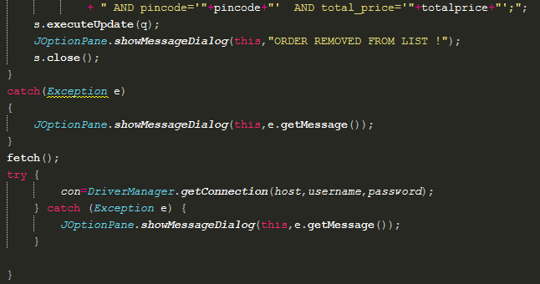

We hear at google works on human-computer phycology, and we also know that you have got bored after seeing this long complex boring lines of code,

MAY BE!!

So, here is a joke to keep you entertained

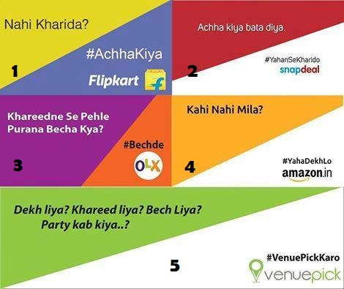

*Snapdeal login frame*

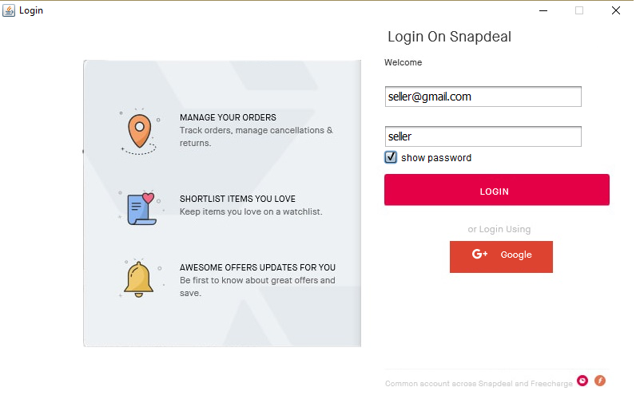

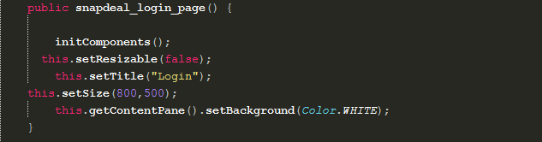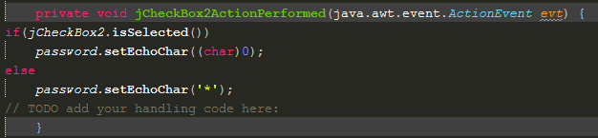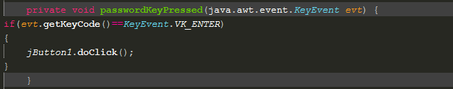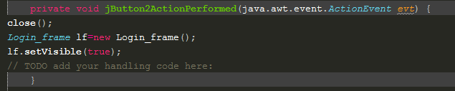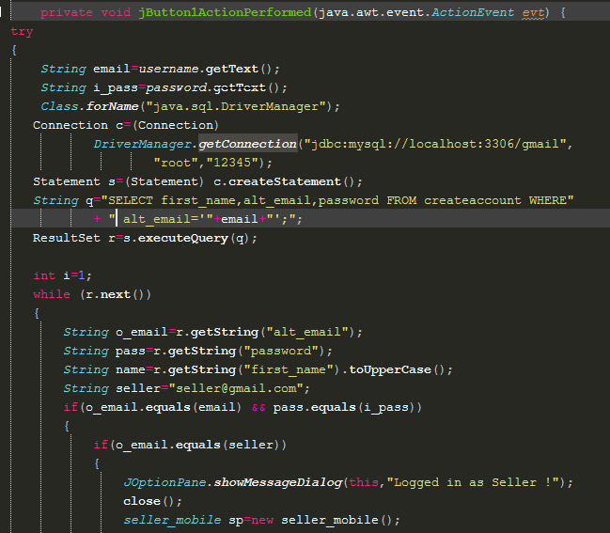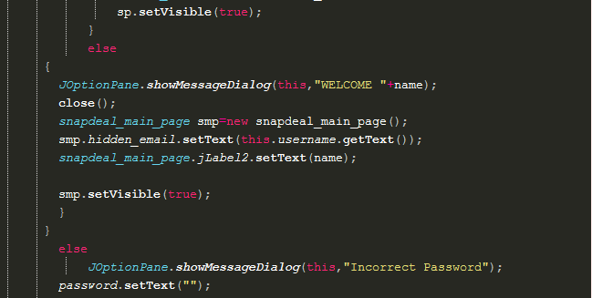

*Google login frame*

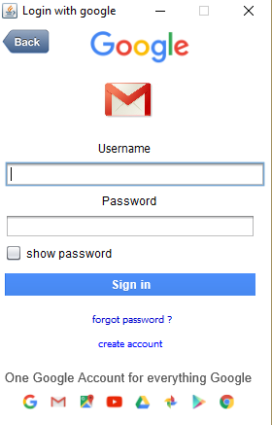

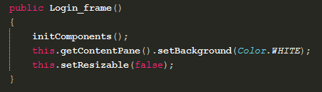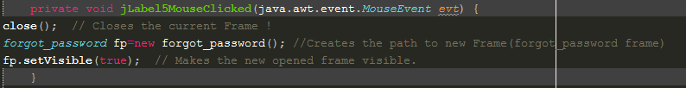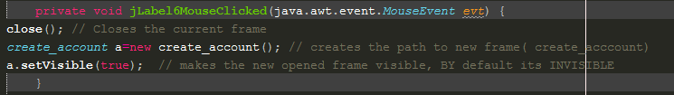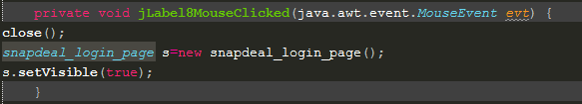

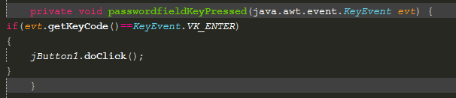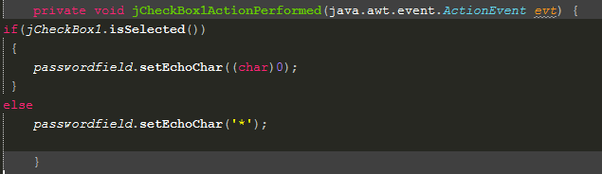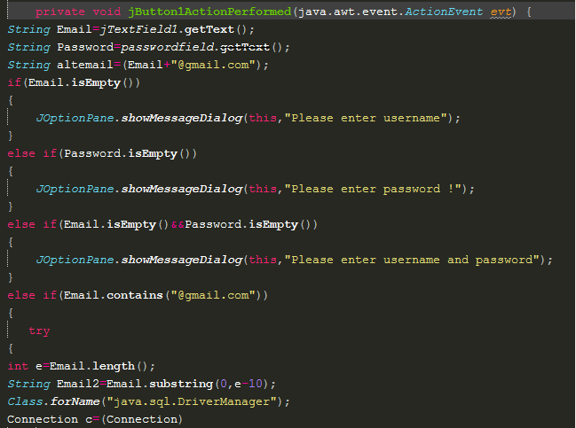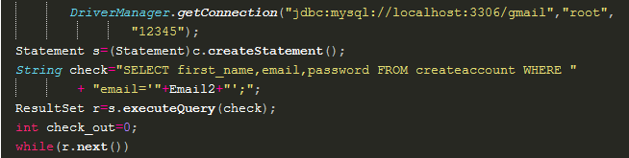

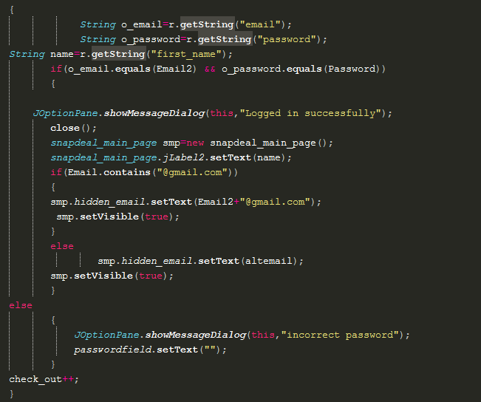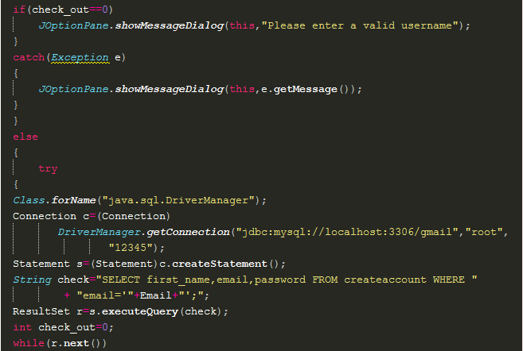

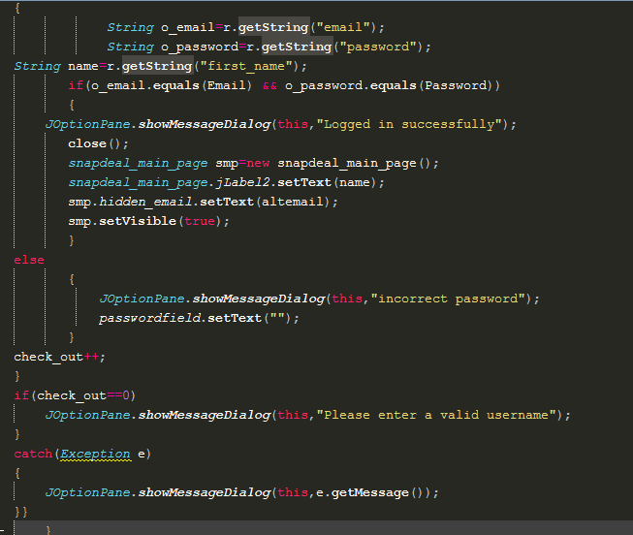

*Forgot password frame*

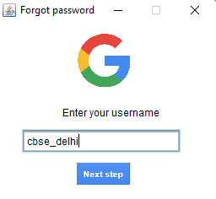

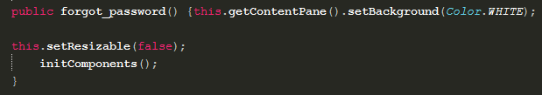

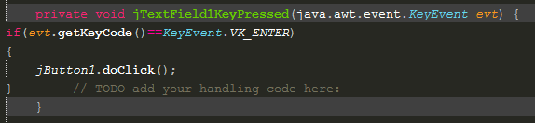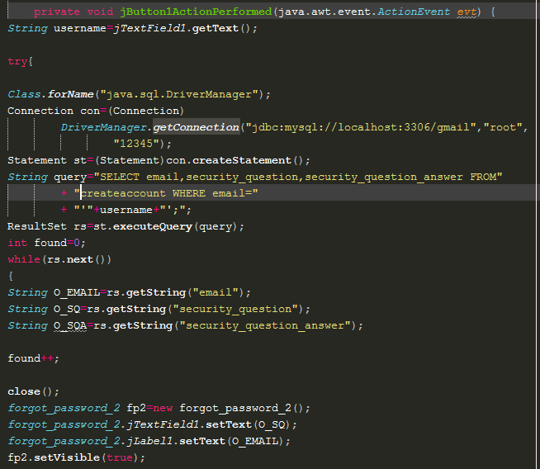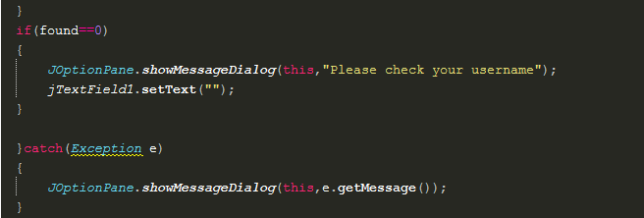

*Forgot password 2 frame*

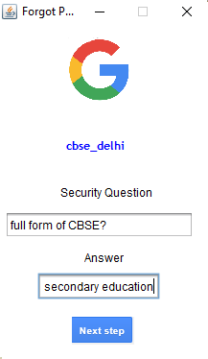

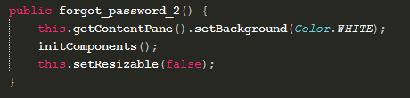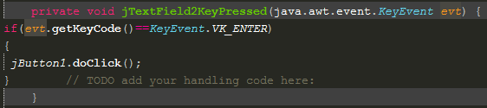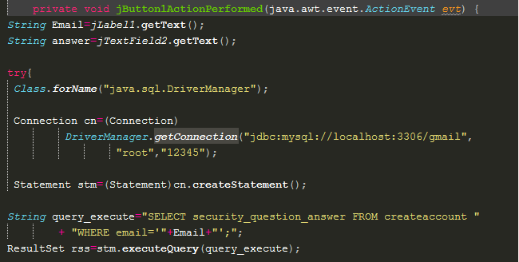

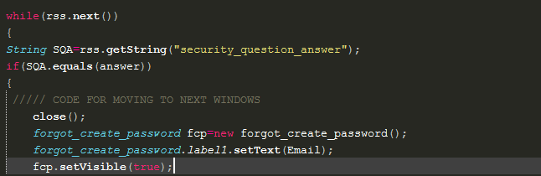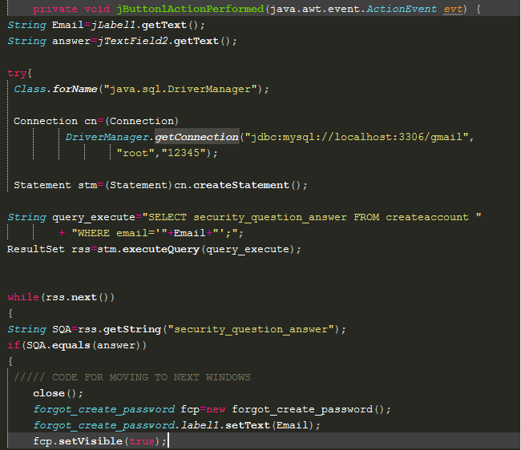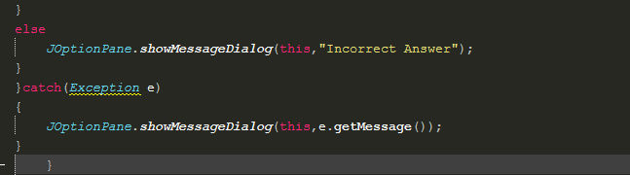

*Forgot create password frame*

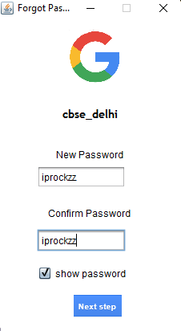

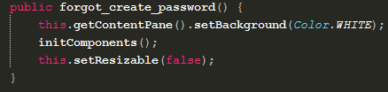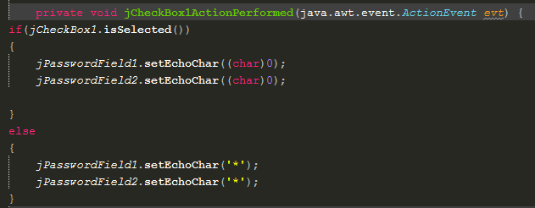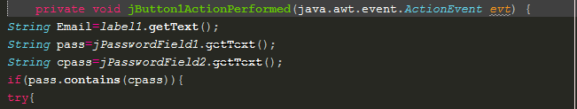

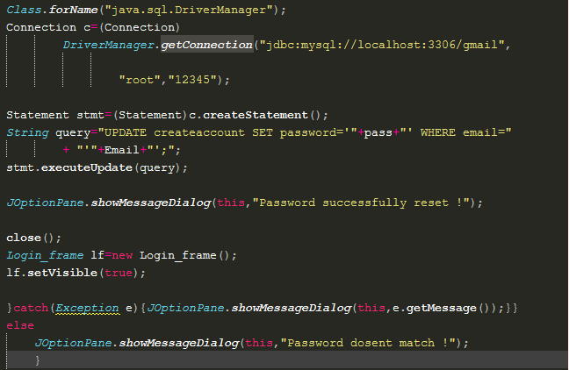

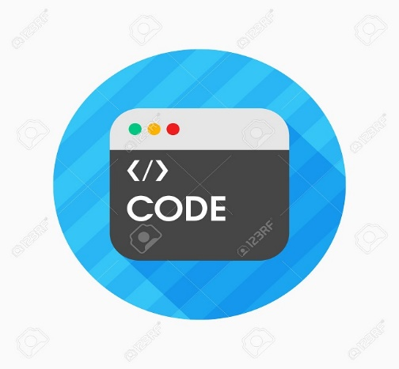

We wind UP here!

Thanks’ for seeing our project,

And yaa as we told that we work on human-computer physiology…. Don’t remember?? That means...

Again, we know that you had not read all the codes!

OK NO PROBLEM, Good Bye!

Once again THANK’s

Bibliography.

This Project would be nearly incomplete if we had not seen and learn new things from the following sites. Our special thanks to the uploader of this great information’s.

And as usual NOTHING HAPPEN’S without this!!

